## TABLE OF CONTENTS

**Contents Page No.**

**CERTIFICATE**  II

**DECLARATION** III

**ACKNOWLEDGEMENT** IV

**ABSTRACT** V

**TABLE OF CONTENT** VI-VII

**LIST OF FIGURES** VIII

# CHAPTER 1: INTRODUCTION…………………………………………….1-4

1.1 OVERVIEW 1.2 MOTIVATION 1.3 OBJECTIVES

**CHAPTER 2: PROBLEM STATEMENT**……………………………………....5

### CHAPTER 3: SOLUTION ………………………………………………….6-9

3.1 OUR WEB APP 3.2 SIMILAR DEPLOYED WEB APPS

### CHAPTER 4: KEY FEATURES……………………………………...……10-12

4.1 USER-FRIENDLY INTERFACE 4.2 MULTI-LANGUAGE SUPPORT 4.3 SPEECH RECOGNITION 4.4 TEXT TRANSLATION 4.5 ACCESSIBILITY AND CUSTOMIZTION 4.6 ENHANCEMENT SECURITY AND PRIVACY 4.7 SCALABILITY AND PERFORMANCE OPTIMIZATION 4.8 FUTURE EXPANSION AND DEVELOPMENT

**CHAPTER 5: TECHNOLOGY STACK**…………………………………….13-15

5.1 FRONTEND DEVELOPMENT

5.2 SPEECH RECOGNITION 5.3 TRANSLATION SERVICE 5.4 API INTEGRATION 5.5 CONTENT DELIVERY NETWORK(CDN) 5.6 HTML 5.7 CSS 5.8 JAVASCRIPT

**CHAPTER 6: FUTURE DEVELOPMENT**……………………………….…16-17

6.1 ENHANCED LANGUAGE SUPPORT 6.2 IMPROVE SPEECH RECOGNITION 6.3 DATABASE INTEGRATION 6.4 OFFLINE FUNCTIONALITY 6.5 ACCESSIBILITY FEATURES 6.6 INTEGRATION WITH ADDITIONAL SERVICES 6.7 PERFORMANCE OPTIMIZATION 6.8 SECURITY ENHANCEMENTS

**CHAPTER 7: WEBSITE INTERFACE**……………………………...……...…18

### CHAPTER 8: DEMO SCENARIO. ………………………………………..19-21

8.1 USER – FRIENDLY INTERFACE 8.2 MULTI-LANGUAGE SUPPORT 8.3 SPEECH RECOGNITION 8.4 TEXT TRANSLATION 8.5 ACCESSIBILITY FEATURES 8.6 SECURITY AND PERFORMANCE 8.7 FUTURE ENHANCEMENTS

### CHAPTER 9: WEBSITE CODE…………………………………….……22-44

9.1 HTML

9.2 CSS 9.3 JAVASCRIPT

### REFERENCE …………………………………………………...…………44

|  |  |  |
| --- | --- | --- |
|  | **LIST OF FIGURES** |  |
| **Fig No.** | **Fig Name** | **Page No.** |
| Fig 7.1 | Web Interface | 18 |
| Fig 9.1 | HTML code I | 24-25 |
| Fig 9.2 | CSS code | 27-34 |
| Fig 9.3 | Java Script | 36 |

**CHAPTER 1**

**INTRODUCTION**

### 1.1 Overview

Translation is necessary for the spreading new information, knowledge, and ideas across the world. It is absolutely necessary to achieve effective communication between different cultures. In the process of spreading new information, translation is something that can change history. In communication, language has been a significant barrier for centuries now, and human beings have always tried to provide a solution to the issues of language translation.

Over the decade's humans have developed different ways of translating languages in other to solve the problems associated with language differences. Real time world contains diffe rent significant messages, labels and useful information but most of them are written in di fferent official languages which depend on the host country. Besides that, it is inconvenie nt for a traveller to carry on their tasks in a foreign country if they don’t understand the la nguage used in that country.

They need to carry a pocket dictionary or use an online translation service in order to unde rstand the message. Optical character recognition (OCR) has been introduced to simplify t he digitization process for users. However, OCR is not able to translate scanned text imag es into different human readable languages.

Therefore, this paper proposed an Android-based application programming interface (API ) developed using Firebase as an improvement text recognition program that is able to tran slate the scanned text images into language of user preference.

This proposed API processes text images, detects text from the scanned images, and transl ates the text into user-preferred languages.

#### 1.2 Motivation

Building a real-time language translator web app with speech recognition is a thrilling endeavor fueled by the aspiration to bridge communication barriers across the globe. In our increasingly interconnected world, language differences often hinder effective interaction, creating a need for accessible, real-time translation tools. This project aims to address this gap, enabling users to communicate seamlessly despite language differences.

The integration of speech recognition adds a layer of immediacy and convenience, allowing users to speak their native language and receive instant translations. This feature is particularly beneficial for travelers, multinational businesses, and educational environments where quick and accurate communication is crucial.

Using HTML, CSS, and JavaScript, this project leverages web technologies to create an intuitive and user-friendly interface. HTML provides the structural foundation, CSS enhances the visual appeal, and JavaScript enables the dynamic functionality necessary for real-time translation and speech recognition. These technologies ensure the application is accessible across different devices and platforms, maximizing its reach and usability. By harnessing the power of modern web technologies, this real-time language translator web app aspires to foster global understanding and collaboration. It is a step towards a world where language is no longer a barrier but a bridge, connecting people from diverse linguistic backgrounds and fostering a more inclusive global community.

Furthermore, the educational implications of this project are vast. By providing real-time translations, the web app can serve as an invaluable tool for language learners, offering them immediate feedback and helping them improve their pronunciation and understanding of a new language. Educators can utilize this technology to create more inclusive classrooms, where students from different linguistic backgrounds can learn together without the constraint of language barriers. Additionally, this project promotes cultural exchange and mutual respect by making it easier for people to access and understand content in foreign languages.

Through this innovative application, we aim to contribute to a world where knowledge and communication are universally accessible, fostering a sense of global unity and cooperation.

#### 1.3 Objectives

The goal of translation practice for non-specialists is to found the language skills of the learner, to refine their thematic and cultural knowledge and to encourage them to think and to react.

The objective of language translator is:

1. Develop a system which able to do conversion between the languages.
2. Provide an easy and simple for translation.
3. Endow good experience to the user.
4. Translate almost each language.
5. To extract effective communication between people around the world.
6. To provide ability for two parties to communicate and exchange the ideas.
7. To encourage learners to discuss the meaning and use of language at the deepest possible levels.
8. To get a challenging position in reputed organization where we can learn a skill by communicating.
9. To perform and translate our native language.

**CHAPTER 2**

**PROBLEM STATEMENTS**

In our globalized world, language barriers continue to pose significant challenges in communication, particularly in real-time interactions. Travelers, businesses, and educational institutions often struggle with the inefficiencies and misunderstandings that arise from language differences. Traditional translation methods, such as written dictionaries or manual translators, are slow and cumbersome, failing to meet the demands of dynamic, real-time conversations. Furthermore, existing digital translation tools often lack accuracy and fail to capture the nuances of spoken language, limiting their effectiveness. There is a clear need for a seamless, real-time translation solution that can bridge these communication gaps. This project addresses this issue by developing a web app that combines speech recognition with instant translation capabilities. By leveraging HTML, CSS, and JavaScript, the app aims to provide users with an intuitive and efficient tool to facilitate accurate, real-time communication across different languages, thereby enhancing global connectivity and understanding.

1. Communication barriers in travel, business, and education
2. The need for real-time, accurate translation
3. The structure of sentences in English and other languages may be different. This is considered to be one of the main structural problems in translation.
4. Limit your Expertise: Gain expertise only in a couple of languages that you are already well-versed in. The translator has to know the exact structure in each language, and use the appropriate structure, and they have to ensure that the translation is performed without changing the meaning as well.

**CHAPTER 3**

**SOLUTIONS**

The solution to overcoming language barriers in real-time communication is the development of a web app that integrates speech recognition with instant translation capabilities. Using HTML for the structural foundation, CSS for visual styling, and JavaScript for dynamic functionality, this application offers a seamless user experience accessible across various devices and platforms. Users can speak in their native language, and the app will immediately recognize the speech and translate it into the desired language, displaying the translated text in real-time. To enhance the user interface, Cloudflare's CDN is utilized for efficient icon delivery, ensuring a fast and visually appealing experience.

The app leverages the MyMemory API for accurate and reliable translations, making it an invaluable tool for travelers, businesses, and educational institutions. Immediate translations help prevent misunderstandings and promote smoother interactions, making the app an essential asset in multilingual environments. The user-friendly interface ensures that even individuals with minimal technical expertise can benefit from the tool, promoting inclusivity.

Additionally, the educational benefits are substantial. Language learners can receive instant feedback on their pronunciation and understanding, while educators can create more inclusive classrooms. This web app also encourages cultural exchange and mutual respect by making foreign language content more accessible. By bridging linguistic divides, this project aims to foster a more connected and understanding world, contributing to global unity and cooperation.

Moreover, the integration of advanced technologies such as Cloudflare's CDN and the MyMemory API not only enhances the functionality but also ensures the reliability and scalability of the web app. Cloudflare's CDN ensures that icons and other assets load quickly and efficiently, providing a smooth and responsive user experience regardless of the user's geographical location. The MyMemory API, known for its extensive and accurate translation database, guarantees that users receive precise translations, thereby improving the overall quality of communication. This robust technical foundation allows the web app to handle high traffic and deliver consistent performance, making it a dependable tool for real-time language translation. By leveraging these cutting-edge technologies, the project underscores its commitment to innovation and excellence, aiming to set a new standard in digital communication tools.

#### 3.1 OUR APP

**App Features:**

##### Real-time translation

1. **Speech-to-Text Translation**: Spoken words are converted into text in the target language, often used in live conversations, meetings, or broadcasts.
2. **Text-to-Text Translation**: Written text is translated in real-time, frequently used in messaging apps, emails, or social media.
3. **Speech-to-Speech Translation**: Spoken language is translated and spoken back in another language, commonly used in travel, customer service, and multilingual events.

##### Online

1. **Copy the Description**: Copy the text you want to translate.
2. **Paste and Select Language**: Paste the copied text into the translation input box and select the target language you want the description to be translated into.
3. **Review the Translation**: Review the output for accuracy. Automated translations can sometimes be imperfect, so it's good to check for any errors.

**3.2. Similar Deployed Web Apps**

1. **Google Translate**

* **Languages Supported**: 100+ languages
* **Notes**: Offers text, speech, image, and website translation. It also has a mobile app for on-the-go translation.

2. **Deep L**

* **Languages Supported**: 30+ languages
* **Notes**: Known for its high-quality translations, especially for European languages. It supports text translation and has a desktop app.

3. **Microsoft Translator**

* **Languages Supported**: 70+ languages
* **Notes**: Provides text, voice, and conversation translation. It also integrates with Microsoft Office and other products.

4. **Reverso**

* **Languages Supported**: 14 languages
* **Notes**: Focuses on context-based translations and provides examples from real-life texts. Also includes a grammar and spell checker.

5. **Yandex. Translate**

* **Languages Supported**: 90+ languages
* **Notes**: Offers text, website, and image translation. Known for its integration with other Yandex services.

6. **SYSTRAN**

* **Languages Supported**: 50+ languages
* **Notes**: Provides professional translation services, including industry-specific translations. It also offers a translation API.

7. **PAPAGO (by Naver)**

* **Languages Supported**: 13 languages
* **Notes**: Popular in East Asia, particularly for Korean, Japanese, and Chinese translations. It includes text, voice, and image translation.

8. **Bing Microsoft Translator**

* **Languages Supported**: 70+ languages
* **Notes**: Similar to Microsoft Translator, with integration into Bing search and other Microsoft products.

9. **PROMT Online Translator**

* **Languages Supported**: 20+ languages
* **Notes**: Focuses on contextual translation and offers specialized dictionaries for different industries.

10. **Translate.com**

* **Languages Supported**: 90+ languages
* **Notes**: Provides both machine and human translation services. Offers text, voice, and image translation.

**CHAPTER 4**

**KEY FEATURES**

##### 4.1 User-Friendly Interface

The real-time language translator web app prioritizes user experience with its intuitive design, ensuring seamless navigation and ease of use. From streamlined menus to clear prompts, every element is crafted to enhance usability, catering to users of varying technical expertise. This approach not only simplifies interaction but also fosters a pleasant and efficient user journey across different devices and platforms.

##### 4.2 Multi-language Support

Supporting a wide array of languages, exceeding 50 in total, the app facilitates fluid communication across diverse linguistic backgrounds. This extensive language coverage empowers users worldwide to engage effortlessly in their native tongue, promoting inclusivity and breaking down language barriers in global interactions. Whether communicating in Spanish, Mandarin, or Arabic, users can expect consistent and reliable translation services that bridge linguistic divides.

##### 4.3 Speech Recognition

Harnessing cutting-edge speech recognition technology, the app swiftly converts spoken language into accurate text, enabling real-time conversations with unparalleled precision. This capability not only enhances the speed of communication but also accommodates various accents and speech patterns, ensuring seamless interaction for users across different regions and linguistic contexts.

##### 4.4 Text Translation

Instant and reliable text translation forms the cornerstone of the app’s functionality, delivering translations with exceptional accuracy and reliability. Whether translating documents, messages, or live conversations, users can rely on the app to maintain clarity and fidelity in conveying meaning across languages. This feature empowers users to communicate effectively and confidently in multilingual environments, supporting diverse scenarios from business negotiations to educational exchanges.

##### 4.5 Accessibility and Customization

The app is designed with accessibility in mind, incorporating features such as adjustable font sizes, contrast options for readability, and compatibility with screen readers. These enhancements ensure inclusivity for users with visual impairments or other accessibility needs, promoting equal access to communication tools across diverse user demographics.

##### 4.6 Enhanced Security and Privacy

Prioritizing user data protection, the app implements robust security measures including encrypted communication channels (HTTPS), data anonymization, and regular security audits. Compliance with international data privacy regulations ensures that user information remains secure and confidential, fostering trust and reliability among users worldwide.

##### 4.7 Scalability and Performance Optimization

Continuous optimization of app performance includes leveraging scalable cloud infrastructure and content delivery networks (CDNs) for fast data transmission and minimal latency. These technologies enable the app to handle increasing user demand while maintaining high responsiveness and reliability, crucial for delivering real-time translation services seamlessly.

##### 4.8 Future Expansion and Development

The roadmap for the app includes ongoing development initiatives such as expanding language support, integrating advanced machine learning algorithms for translation accuracy improvement, and enhancing user interface with AI-driven features for predictive text input and context-aware translations. These advancements aim to further elevate the app’s capabilities, ensuring it remains at the forefront of language translation technology and continues to meet the evolving needs of global users.

These robust features collectively position the app as an indispensable tool for overcoming language barriers in various contexts, fostering global connectivity, and promoting mutual understanding. Whether facilitating international travel, enhancing business communications, or enriching educational experiences, the app’s capabilities ensure efficient and accessible communication across the globe, paving the way for enhanced cultural exchange and collaboration.

**CHAPTER 5**

**TECHNOLOGY STACK**

**The technology stack** behind the real-time language translator web app combines a range of modern tools and frameworks to deliver a robust and efficient user experience. Here’s an overview of the key components:

##### 5.1. Frontend Development

The frontend of the web app is primarily built using HTML, CSS, and JavaScript. HTML (HyperText Markup Language) forms the structural foundation of the application, defining the layout and content structure. CSS (Cascading Style Sheets) is used for styling and design, ensuring a visually appealing and user-friendly interface. JavaScript, being a versatile scripting language, adds interactivity and dynamic functionality to the app. It handles tasks such as user input processing, real-time updates, and integration with backend services.

##### 5.2. Speech Recognition

For speech-to-text conversion, the web app integrates with the Web Speech API, a modern browser API that allows developers to incorporate speech recognition capabilities into web applications. This API supports real-time speech recognition directly within the browser, providing accurate transcription of spoken language into text format. This feature enhances usability by enabling users to input text effortlessly through voice commands, ideal for scenarios requiring hands-free interaction.

##### 5.3. Translation Service

The core translation functionality is powered by the MyMemory API. This API offers extensive language translation capabilities, leveraging a vast database to provide accurate translations across multiple languages in real-time. It supports various language pairs and ensures high translation accuracy, essential for effective communication across global audiences. The integration with MyMemory API enhances the app’s reliability and performance in delivering precise translations promptly.

##### 5.4. API Integration

The real-time language translator web app integrates with the MyMemory API for comprehensive language translation capabilities. This API taps into a vast database to provide accurate and real-time translations across multiple languages. API integration is managed using JavaScript's Fetch API or Axios library, making asynchronous HTTP requests to retrieve translation data. The app processes API responses dynamically, updating the user interface with translated text in real-time. This seamless integration ensures high translation accuracy and reliability, enhancing the app's functionality and usability for users navigating multilingual environments.

##### 5.5 Content Delivery Network (CDN)

To optimize performance and ensure fast delivery of static assets such as icons and images, the app integrates with Cloudflare’s CDN (Content Delivery Network). CDN accelerates content delivery by caching assets on globally distributed servers closer to users, reducing latency and improving load +. This ensures a smooth and responsive user experience, particularly beneficial for users accessing the app from different geographical locations.

#### 5.6. HTML

HTML5 forms the foundational structure of the real-time language translator web app, providing the essential markup for content and layout. Elements such as <div>, <input>, and <button> are strategically utilized to organize and present various components of the user interface, ensuring clarity and ease of interaction. Semantic HTML tags like <header>, <main>, and <footer> contribute to a well-structured document outline, enhancing accessibility and search engine optimization (SEO). HTML5 features such as <audio> and <video> tags could potentially enrich the user experience by supporting multimedia elements as needed.

#### 5.7. CSS

CSS3 plays a crucial role in styling and enhancing the visual presentation of the web app. Cascading Style Sheets define colours, typography, spacing, and responsive layout properties across different screen sizes and devices. Selectors, combinators, and pseudoclasses target specific elements to apply custom styles, ensuring consistency and aesthetic appeal throughout the application. Utilization of CSS frameworks like Bootstrap or custom CSS grids streamlines layout design and ensures compatibility across various browsers and platforms. Media queries are employed to implement responsive design, adapting the app's layout and content presentation based on the user's device, optimizing the user experience across desktops, tablets, and smartphones.

##### 5.8. JavaScript (ES6+)

JavaScript serves as the backbone of the app's dynamic functionality, enabling interactive features and real-time updates. ES6+ features such as arrow functions, template literals, and destructuring assignments are leveraged for writing concise and efficient code. Event listeners handle user interactions such as button clicks and input changes, triggering actions like speech recognition initiation and API requests for translation. Asynchronous programming with promises or async/await syntax ensures smooth handling of API responses, facilitating seamless integration of speech-to-text conversion and translation services.

By leveraging HTML5, CSS3, JavaScript (ES6+), and API integration, the real-time language translator web app offers a sophisticated yet accessible tool for overcoming language barriers. This technology stack not only ensures a responsive and visually appealing interface but also facilitates efficient communication across diverse linguistic backgrounds, empowering users with seamless translation capabilities.

This technology stack ensures the real-time language translator web app is not only efficient and reliable but also scalable to meet the demands of a diverse user base. By leveraging these technologies, the app facilitates seamless communication across different languages, enhancing global connectivity and understanding.

**CHAPTER 6**

**FUTURE DEVELOPMENT**

Future development of the real-time language translator web app encompasses several strategic enhancements across various aspects of functionality and infrastructure:

##### 1. Enhanced Language Support

Expand language support to encompass additional languages, dialects, and regional variations, catering to a broader global audience. This expansion may involve integrating more comprehensive translation APIs or implementing machine learning models to improve translation accuracy and coverage.

##### 2. Improved Speech Recognition

Incorporate advancements in speech recognition technology to enhance accuracy, speed, and support for diverse languages and accents. Integration with natural language processing (NLP) techniques could enable better understanding of context and intent in spoken language, thereby improving overall user experience.

##### 3. Database Integration

Introduce database integration to enhance user experience and functionality. Implementing a lightweight database solution such as MongoDB or Firebase could facilitate user preferences storage, session management, and personalized settings. This would enable features like user history tracking, favourite translations, and customized language settings, enhancing usability and personalization.

##### 4. Offline Functionality

Develop offline capabilities to enable basic translation features without requiring an internet connection. This could involve implementing local data storage on the client-side for cached translations and offline speech recognition models, ensuring usability in lowconnectivity environments.

##### 5. Accessibility Features

Enhance accessibility by implementing support for screen readers, keyboard navigation improvements, and adherence to web accessibility standards (WCAG). Ensuring compliance with accessibility guidelines makes the app more inclusive and usable for individuals with disabilities.

##### 6. Integration with Additional Services

Explore integration with complementary services such as real-time text-to-speech conversion, cultural context indicators in translations, or integration with popular communication platforms for seamless multilingual communication.

##### 7. Performance Optimization

Continuously optimize app performance by refining codebase, leveraging browser caching, and minimizing network latency. Integration with advanced content delivery networks

(CDNs) and serverless computing could further improve scalability, speed, and reliability.

##### 8. Security Enhancements

Strengthen data security measures with secure communication protocols (HTTPS), data encryption, and regular security audits. Prioritizing user data protection builds trust and ensures compliance with data privacy regulations.

These strategic developments aim to elevate the real-time language translator web app's capabilities, positioning it as a leading solution for global communication needs while embracing technological advancements and user-centric enhancements.

**CHAPTER 7**

**WEB INTERFACE**

A simple and user- friendly user interface for providing best experience.

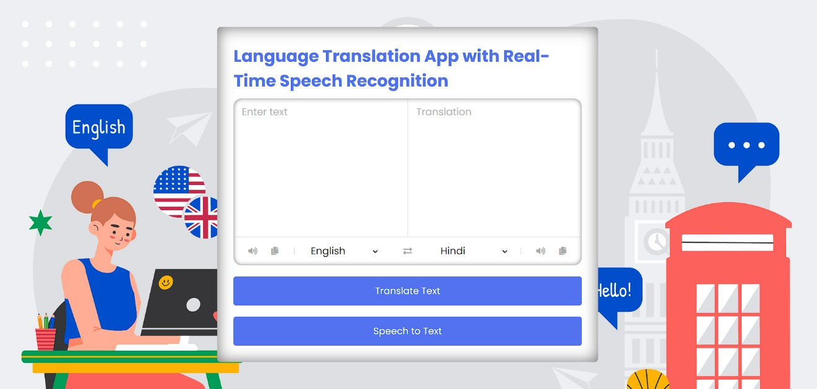

Before translation

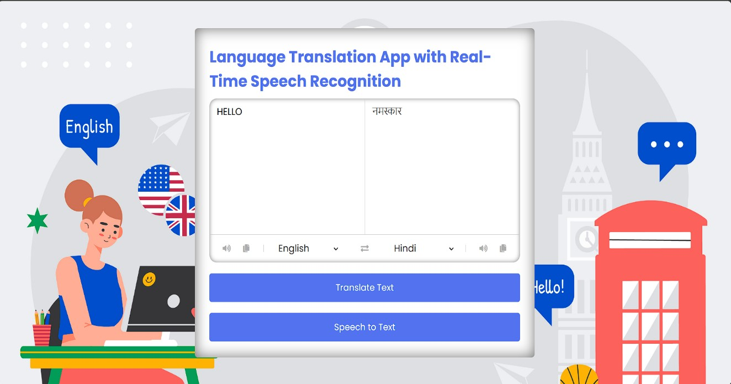

After translation

Fig.7.1: Website interface.

**CHAPTER 8**

**DEMO SCENARIO**

##### 1. User-Friendly Interface

Upon launching the app, users encounter a sleek and intuitive interface designed for simplicity and efficiency. Navigation is straightforward, with clearly labelled menus and prominent language selection options. The layout is responsive, adapting seamlessly to different screen sizes and orientations, ensuring a consistent experience across devices. Interactive elements such as buttons and input fields are strategically placed for ease of access, enhancing usability for users of all technical proficiencies.

##### 2. Multi-language Support

Selecting English as the default language, users input a phrase in the text box. They then choose Spanish from the dropdown menu, demonstrating the app's capability to translate between diverse languages seamlessly. The dropdown menu includes a comprehensive list of supported languages, categorized for easy navigation. Users can switch between languages effortlessly, ensuring flexibility and accommodating multilingual communication needs in various contexts, from travel to business meetings.

##### 3. Speech Recognition

Activating the microphone icon, users speak a phrase in English, "Good morning, how are you?" The app instantly converts the spoken words into accurate text, displayed in realtime below the input field. Advanced speech recognition technology ensures high accuracy even with different accents and speech variations, providing reliable transcription for effective communication.

##### 4. Text Translation

With a click on the translate button, the app swiftly translates the English text into Spanish, maintaining fidelity and clarity of the original message. Users can see the translated text appear instantly, ensuring effective communication across language barriers. Translation results are displayed prominently, with options for users to copy, share, or further modify the translated text, enhancing usability and convenience.

##### 5. Accessibility Features

The app includes accessibility enhancements such as resizable text options and highcontrast themes, ensuring usability for users with different visual preferences and needs. Keyboard shortcuts and voice command options are integrated to provide alternative navigation methods, catering to users with disabilities or limited dexterity. These features comply with web accessibility standards (WCAG), promoting inclusivity and ensuring equal access to language translation tools.

##### 6. Security and Performance

Demonstrating secure data transmission with HTTPS encryption, the app prioritizes user privacy and protection. Its integration with a robust CDN ensures fast performance and minimal latency, delivering a seamless translation experience. Regular updates and maintenance ensure that the app remains secure against potential vulnerabilities, maintaining user trust and confidence in its reliability.

##### 7. Future Enhancements

Discuss upcoming features such as expanded language support, integration with AI for context-aware translations, and offline functionality for enhanced user convenience. Planned updates aim to improve translation accuracy through machine learning algorithms, enhance user interface design for better usability, and introduce new features based on user feedback and evolving technological advancements.

This extended demo provides a deeper insight into the real-time language translator web app's functionality, emphasizing its user-centric design, robust capabilities, and commitment to accessibility, security, and continuous improvement.

**CHAPTER 9**

**WEBSITE CODE**

#### 9.1 HTML

##### 1. Meta Tags and Title

The <meta> tags specify character encoding, viewport settings for responsiveness, and include a title for the web app.

**2. External Stylesheet**

The <link> tag imports an external CSS file (style.css) for styling the app components.

##### 3. Font Awesome Icons

The Font Awesome CDN link imports icon styles for visual elements like volume, copy, and exchange icons used throughout the app.

##### 4. Container and Heading

The <div class="container"> holds the entire content of the app. Inside it, <div class="heading"> displays the title of the app.

##### 5. Text Input Section

<div class="text-input"> contains two <textarea> elements:

* from-text for user input.
* to-text for displaying translated text (readonly and disabled).

##### 6. Language Controls

<ul class="controls"> organizes language selection controls:

* <li class="row from"> for selecting input language with icons and dropdown.
* <li class="exchange"> for exchanging input and output languages.
* <li class="row to"> for selecting output language with icons and dropdown.

##### 7. Buttons

Two <button> elements:

* First button initiates text translation.
* Second button triggers speech-to-text functionality through a JavaScript function record().

##### 8. JavaScript Imports

Three <script> tags import JavaScript files:

* countries.js for language data.
* script.js for app functionality.
* voiceToText.js for speech recognition integration.

HTML is the standard language used to create and design web pages. It provides the basic structure of a webpage, which is then enhanced and modified by other technologies like CSS and JavaScript. HTML is the foundation of web development, and understanding its basics is crucial for creating well-structured and accessible web pages. HTML uses tags to create elements. Tags are enclosed in angle brackets, like <p> for a paragraph or <h1> for a heading. Most tags come in pairs: an opening tag <p> and a closing tag </p>. HTML provides six levels of headings, from <h1> (the most important) to <h6> (the least important). These are used to structure content hierarchically. You can create hyperlinks using the <a> tag and embed images using the <img> tag. The src attribute of the <img> tag specifies the path to the image file.

This structured **HTML** sets the foundation for the real-time language translator web app, incorporating essential elements for user interaction, language selection, and integration with external JavaScript functionality for translation and speech recognition capabilities.

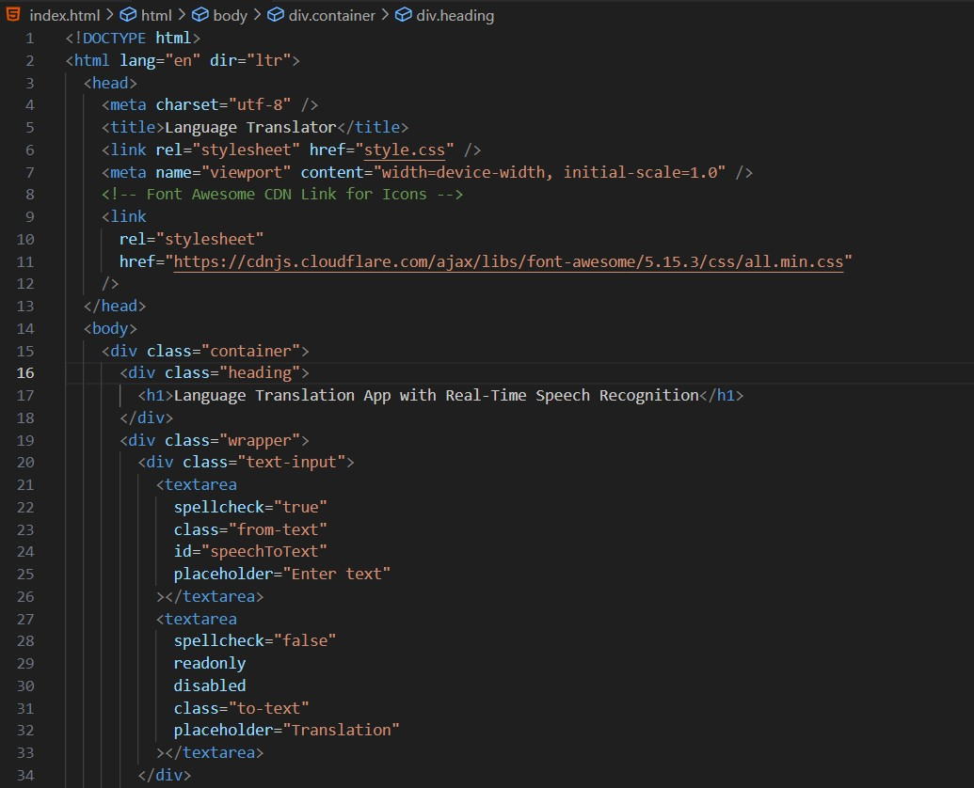

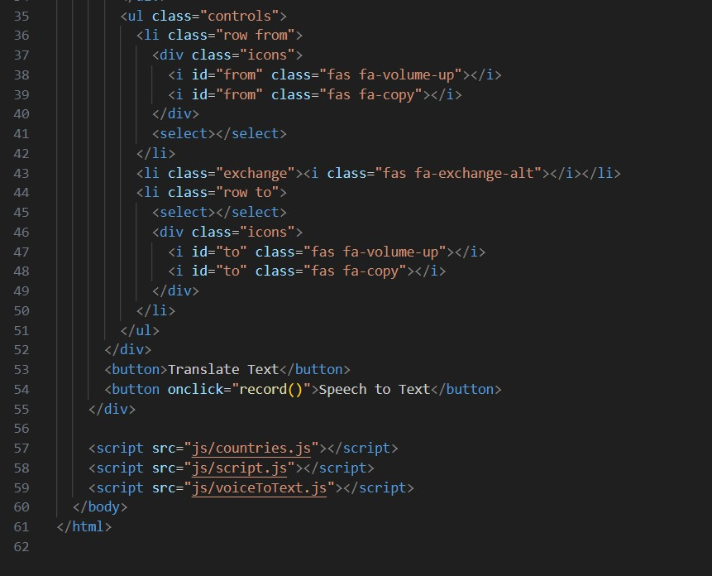

Fig. 9.1: The HTML code used in this project

In last lines, we added three JavaScript files for functionality. Names are –

1. Countries. Js
2. Script.js
3. voicetoText.js

## 9.2 CSS

The CSS stylesheet plays a pivotal role in defining the visual presentation and user interface of the real-time language translator web app. It integrates the Poppins font from Google Fonts, chosen for its clarity and modern appeal, ensuring a consistent typography throughout. The overall layout is structured using flexbox, which centrally aligns content and adjusts padding for optimal viewing across devices. The background image is strategically employed to enhance the app's ambiance without distracting from functionality.

Within the container div, which envelops the core content, styles include a clean white background with rounded corners and a subtle box shadow, imparting a polished look and focusing attention on the translation interface. Textareas, critical for input and output, are customized to be borderless, non-resizable, and feature placeholder text for user guidance.

User controls such as select menus and icons are arranged in rows using flexbox, ensuring uniform spacing and alignment. Hover effects on icons provide visual feedback, enhancing usability. Responsive design principles are implemented via media queries, enabling the app to adapt seamlessly to various screen sizes and orientations, thereby optimizing the user experience across desktops, tablets, and smartphone.

### 1. Global Reset and Typography

Resets margin, padding, and box-sizing for all elements (*). Sets the font-family to 'Poppins' for a consistent typography throughout the app.

### 2. Body and Background

Styles the body (body) to center content (display: flex; align-items: center; justify-content: center;). Sets a background image (background-image) that covers the viewport (background-size: cover;).

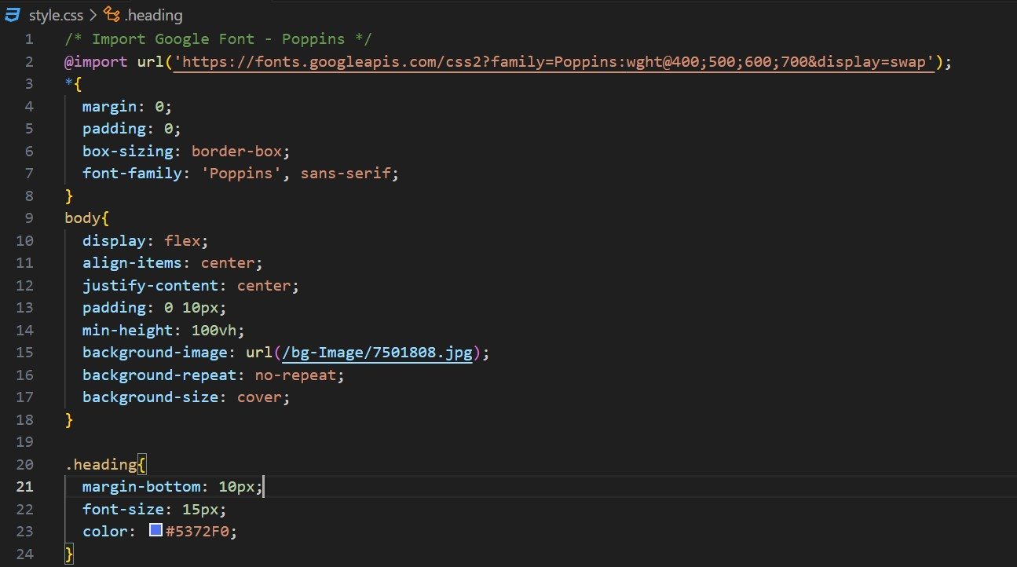

Fig. 9.2: Importing font from google

### 3. Container and Wrapper

Defines styles for the main container (container) and its wrapper (wrapper) with specific dimensions, padding, background, border-radius for rounded corners, and box-shadow for a subtle depth effect.

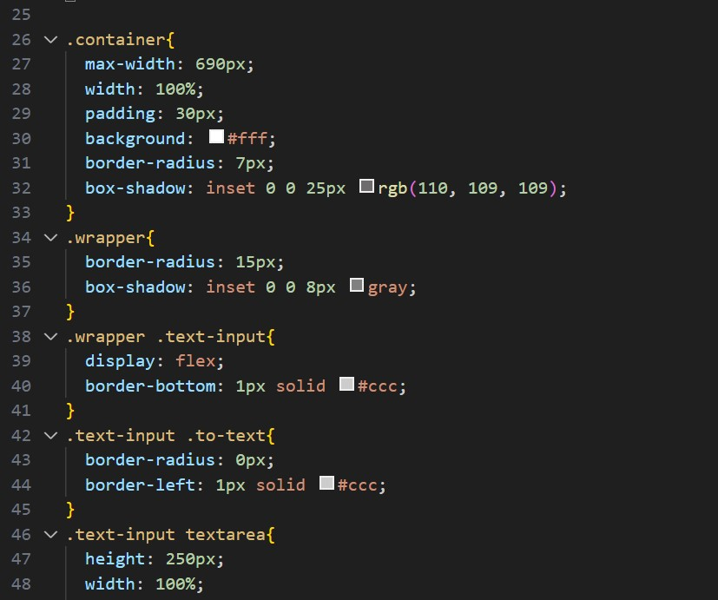

Fig. 9.2.1: container and wrapper class

### 4. Text Input Section

Customizes the text input area (textarea) for user input with specific height, width, border, padding, and border-radius. Placeholder text (::placeholder) is styled to appear in a light gray color (#b7b6b6).

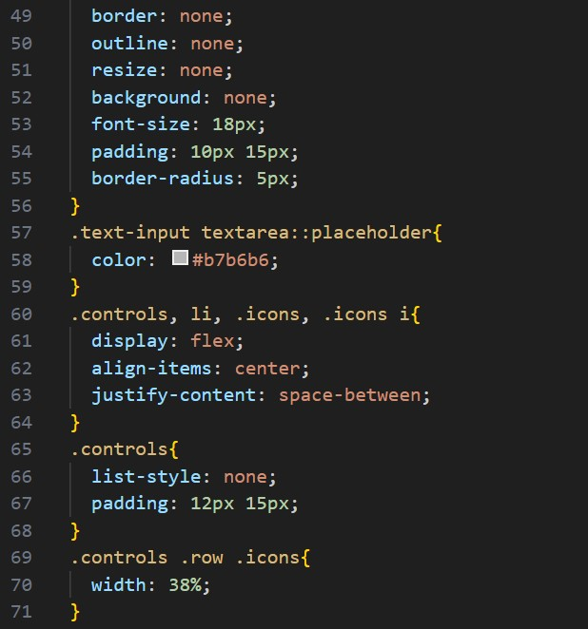

Fig. 9.2.2: Textarea of input field

### 5. Controls and Icons

Styles the language selection controls (controls) with a flex layout, aligning items and providing space between them (justify-content: space-between;). Icons (icons i) are customized for color, size, cursor pointer, and transition effect (transition: transform 0.2s ease;).

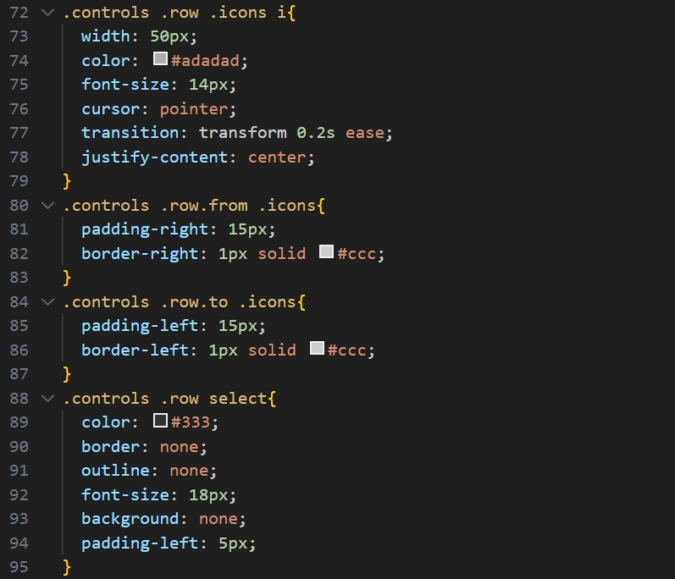

Fig. 9.2.3: Icons customization

### 6. Scrollbar Customization

Customizes the scrollbar appearance (::-webkit-scrollbar, ::-webkit-scrollbar-thumb, ::webkit-scrollbar-track) for the text input area and language selection dropdown (select), ensuring a consistent user interface across browsers.

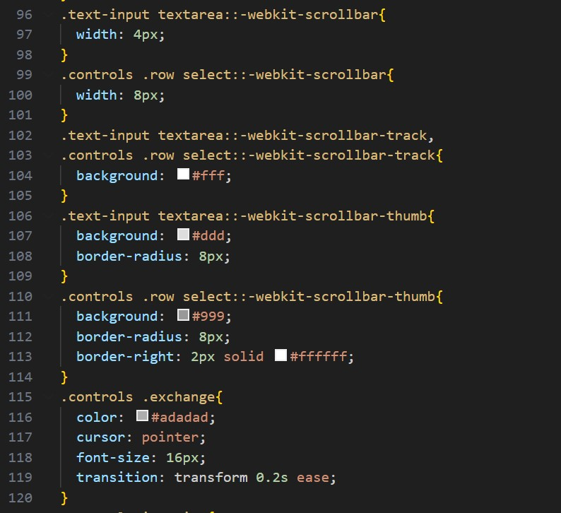

Fig. 9.2.4: Customizing the Scrollbar

### 7. Exchange Button and Button Styles

Defines styles for the exchange button (exchange) with color, cursor pointer, font size, and transition effect. Buttons (container button) are styled for width, padding, color, cursor pointer, margin-top for spacing, font size, border-radius for rounded corners, and background color (background: #5372F0;).

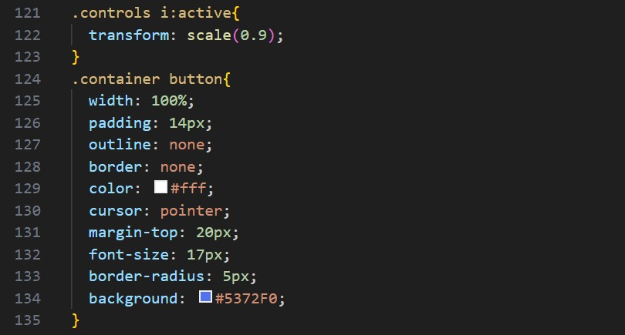

Fig. 9.2.6: Psuedo code (customizing button when it was active)

### 8. Responsive Design

Responsive design is crucial for ensuring that the real-time language translator web app functions seamlessly across different devices and screen sizes. Implemented through CSS media queries, it enables the app to adapt its layout and content presentation dynamically. For instance, the app's interface adjusts fluidly from a desktop view with comprehensive controls to a more compact layout on mobile devices, where space is optimized and unnecessary elements are hidden or rearranged.

Key elements like textareas for input and output resize proportionally, ensuring readability and usability remain intact. User controls, such as select menus and icons, scale appropriately, maintaining functionality without sacrificing ease of interaction. This approach not only enhances user accessibility but also extends the app's usability across a broad spectrum of devices, from large desktop monitors to smaller smartphones, ensuring a consistent and enjoyable experience regardless of how users access the application.

This comprehensive CSS code enhances the visual aesthetics, functionality, and responsiveness of the real-time language translator web app, ensuring a seamless and userfriendly experience across different devices and screen sizes.

**Media query** (@media (max-width: 660px)) adjusts styles for smaller screens, optimizing layout (flex-direction: column; for text input wrapper), padding, font sizes, and hiding icons (display: none;) to enhance usability and readability on mobile devices.

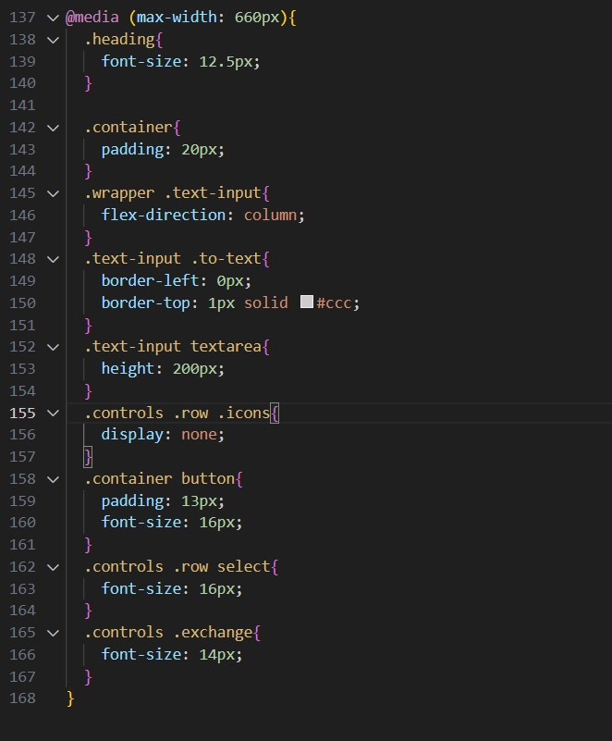

Fig. 9.2.6: Media query for responsive

## 9.3 JavaScript

JavaScript Is lightweight, cross-platform, single-threaded, and interpreted compiled programming language. It is also known as the scripting language for webpages. It is well-known for the development of web pages, and many non-browser environments also use it.

JavaScript is a[weakly typed language](https://www.geeksforgeeks.org/type-systemsdynamic-typing-static-typing-duck-typing/) (dynamically typed). JavaScript can be used for [Client-side](https://www.geeksforgeeks.org/server-side-client-side-programming/) developments as well as [Server-side](https://www.geeksforgeeks.org/server-side-client-side-programming/) developments. JavaScript is both an imperative and declarative type of language. JavaScript contains a standard library of objects, like [Array,](https://www.geeksforgeeks.org/arrays-in-javascript/) [Date,](https://www.geeksforgeeks.org/javascript-date-objects/) and [Math,](https://www.geeksforgeeks.org/javascript-math-object/) and a core set of language elements like [operators,](https://www.geeksforgeeks.org/javascript-operators/) control structures, and [statements.](https://www.geeksforgeeks.org/javascript-statements/)

### • Client-side

It supplies objects to control a browser and its [Document Object Model (DOM).](https://www.geeksforgeeks.org/dom-document-object-model/) Like if client-side extensions allow an application to place elements on an HTML form and respond to user events such as mouse clicks, form input, and page navigation. Useful libraries for the client side are [AngularJS,](https://www.geeksforgeeks.org/introduction-to-angularjs/) [ReactJS,](https://www.geeksforgeeks.org/react-js-introduction-working/) [VueJS,](https://www.geeksforgeeks.org/vue-js/) and so many others.

### • Server-side

It supplies objects relevant to running JavaScript on a server. For if the server-side extensions allow an application to communicate with a database, and provide continuity of information from one invocation to another of the application, or perform file manipulations on a server. The useful framework which is the most famous these days is [node.js.](https://www.geeksforgeeks.org/introduction-to-nodejs/)

### • Imperative language

In this type of language we are mostly concerned about how it is to be done. It simply controls the flow of computation. The procedural programming approach, object, oriented approach comes under this as async await we are thinking about what is to be done further after the async call.

### • Declarative programming

In this type of language we are concerned about how it is to be done, basically here logical computation requires. Her main goal is to describe the desired result without direct dictation on how to get it as the arrow function does.

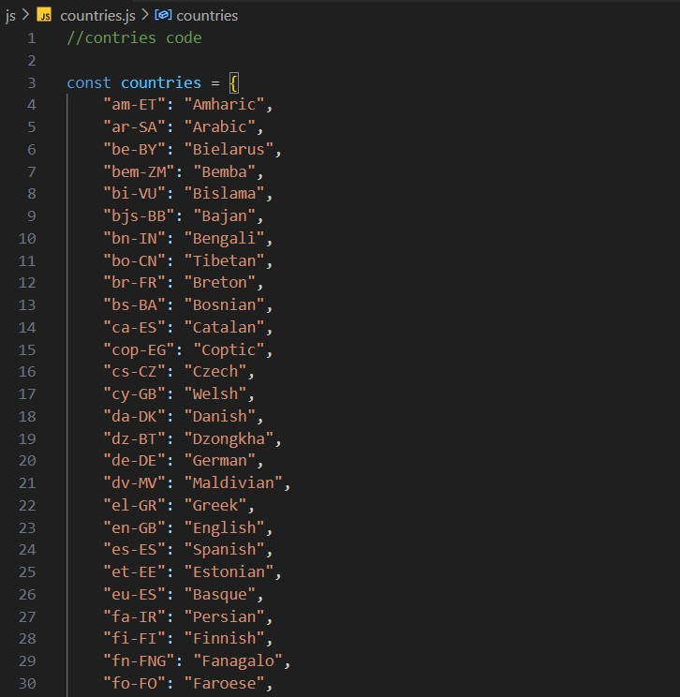

Fig. 9.3.1: The countries object in JavaScript serves as a mapping between language codes (keys) and their corresponding language names (values).

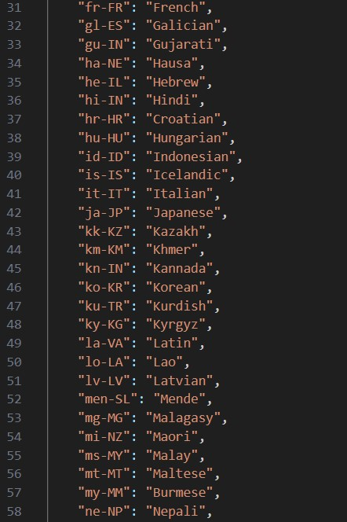

Fig. 9.3.2: mapping with code values

## Key Points

### 1. Purpose

• This object is designed to provide a quick reference for translating language codes into human-readable language names. Each key-value pair associates a unique language code with its corresponding language name.

### 2. Structure

* **Keys**: Each key represents a language code in the format xx-YY, where xx is the ISO 639-1 code (two-letter language code) and YY is the ISO 3166-1 alpha-2 code (twoletter country code).
* **Values**: Each value is the name of the language represented by the key.

**3. Usage**:

• In your application, you can use this object to dynamically populate dropdown menus or other UI elements where users can select languages. For example, when a user selects a language, you can retrieve the corresponding language name from this object and display it in the UI.

**4. Example**:

• If you access countries["en-GB"], it will return "English", indicating that the language code "en-GB" represents the English language.

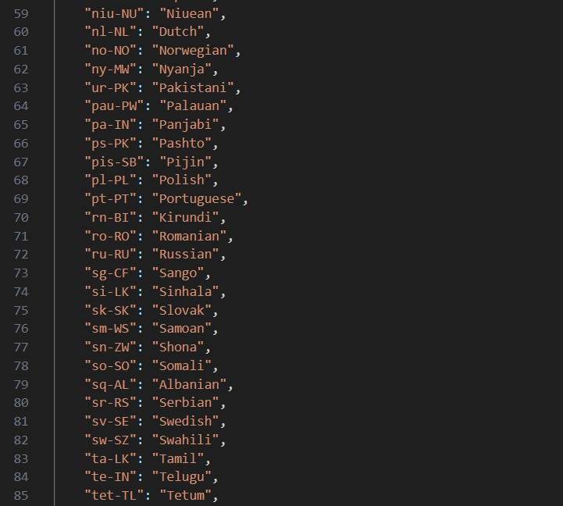

Fig. 9.3.3: mapping

## Benefits

* **Efficiency**: Provides a centralized and efficient way to manage language data without hardcoding language names throughout your application.
* **Clarity**: Makes your code more readable and maintainable by using descriptive language names rather than cryptic language codes.

## Application

• This countries object is particularly useful in multilingual applications, such as language translators, where users need to select languages for translation or communication.

By utilizing this object, you streamline language handling in your application, enhancing both usability and maintainability. If you have any specific use cases or need further assistance, feel free to ask!

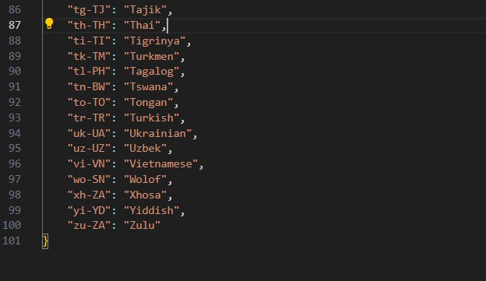

Fig. 9.3.4: mapping of country code

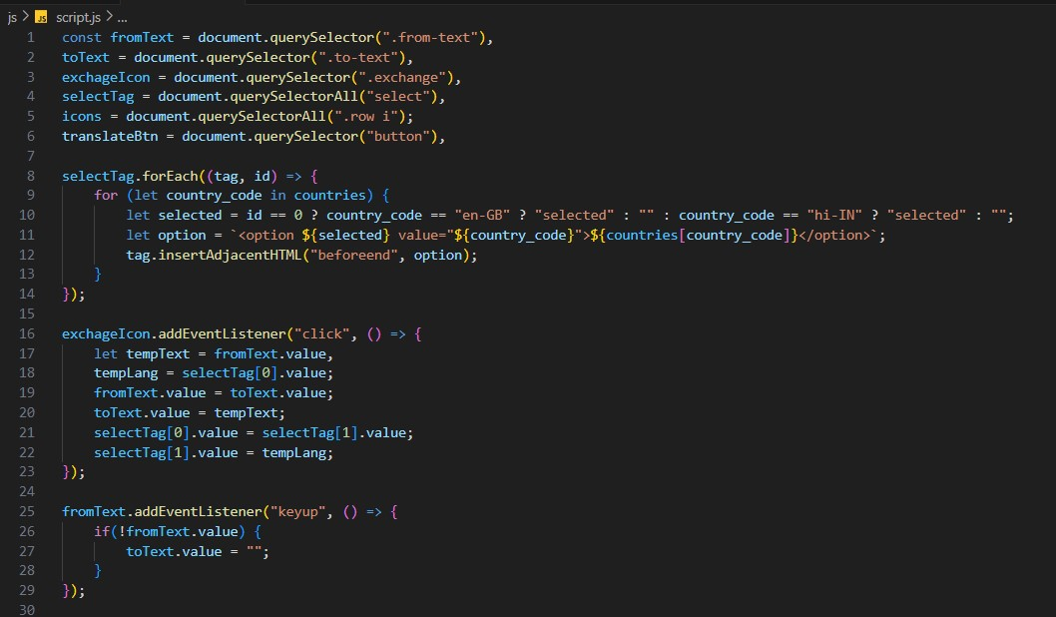

Fig. 9.3.5: Event listeners in JavaScript

### 1. Selecting DOM Elements

• The querySelector and querySelectorAll methods are used to select various HTML elements based on their CSS classes (from-text, to-text, exchange, row, i) and tag name (select, button).

### 2. Populating Dropdowns

• The selectTag.forEach loop iterates over each select element (tag) found in the DOM. For each select, it dynamically creates option elements based on the countries object, setting the selected attribute based on the index (id) of the loop.

### 3. Handling Exchange Icon Click

• When the exchange icon (exchangeIcon) is clicked, the text values of fromText and toText are swapped, and the selected languages in the dropdowns (selectTag) are also swapped.

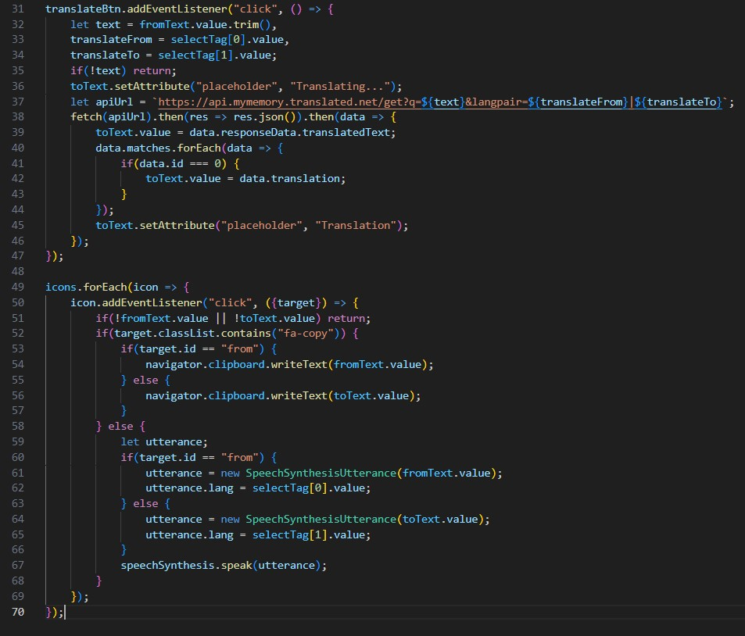

Fig. 9.3.6: fetching APIs

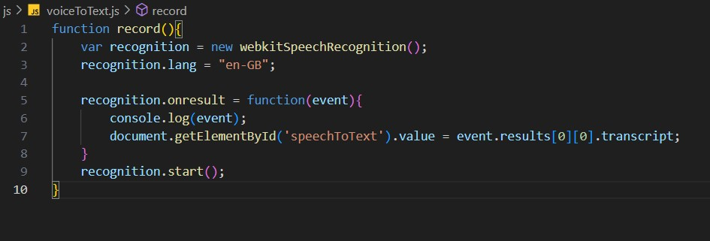

Fig. 9.3.7: Voice To Text code implementation

### 1. Creating a Speech Recognition Instance

• var recognition = new webkitSpeechRecognition();: This line creates a new instance of the webkitSpeechRecognition object, which is part of the Web Speech API. This object allows the web application to recognize speech input from the user.

### 2. Setting Recognition Language

• recognition.lang = "en-GB";: This sets the language for speech recognition to British English (en-GB). This means the recognizer will attempt to interpret spoken language input in British English.

### 3. Handling Recognition Results

• recognition.onresult = function(event) { ... }: This event handler is triggered when the speech recognition system has detected speech and processed it into text. The event object contains the result of the recognition process.

### 4. Extracting and Displaying Transcription

* console.log(event);: This logs the entire event object to the console, providing detailed information about the recognition results.
* document.getElementById('speechToText').value = event.results[0][0].transcript;:

This line extracts the transcribed text from the recognition result

(event.results[0][0].transcript) and sets this text as the value of an element with the id of speechToText. This typically updates a textarea or input field on the webpage with the recognized speech.

### 5. Starting the Recognition

• recognition.start();: This method starts the speech recognition service. Once started, the browser will listen for speech input from the user based on the specified language (enGB in this case).

### Usage

• This function record() is typically called in response to an event, such as clicking a button labeled "Record" or similar. When the function executes, it initializes speech recognition, listens for speech input in British English, and updates the specified HTML element (speechToText) with the recognized speech.

#### Summary

This JavaScript function integrates speech recognition capabilities into a web application, allowing users to provide input via spoken language. It demonstrates how to set up and utilize the Web Speech API for speech-to-text functionality, enhancing user interaction and accessibility on the web.

## REFERENCE

Here are some references for books on creating a language translator app with real-time speech recognition using HTML, CSS, and JavaScript:

1. JavaScript: “The Definitive Guide” by David Flanagan.
2. HTML and CSS: “Design and Build Websites” by Jon Duckett.
3. Eloquent JavaScript: “A Modern Introduction to Programming” by Marijn Haverbeke.
4. Learning Web Design: “A Beginner's Guide to HTML, CSS, JavaScript, and Web Graphics” by Jennifer Niederst Robbins.
5. JavaScript and JQuery: “Interactive Front-End Web Development” by Jon Duckett.
6. Pro HTML5 Programming: “Powerful APIs for Richer Internet Application Development” by Peter Lubbers, Brian Albers, and Frank Salim.
7. API: “Web Audio API" by Boris Smus.
8. Natural Language Processing: "Speech and Language Processing" by Daniel Jurafsky and James H. Martin.